Intelligent Data Logger: data strategy
What to show, what to build next, and what to leave alone
Petgrave.io edition (research and product team) · 17 October 2026
Status: Provisional: before any field data; revisit after the first pilot month
The one thing to see differently
The obvious next step for an AI data logger is more AI, or our own hardware. The evidence points somewhere else. On synthetic data, our method gets 233 of 240 diagnoses right when it can see history across all components. In the field, we would have no way to know whether a diagnosis was right, because nobody writes down what the installer actually found when they go back. Six of the seven installers asked had one or two such return visits a year. Those visits are the cheapest ground truth there is. The first thing to collect is a two-line note, not more telemetry.
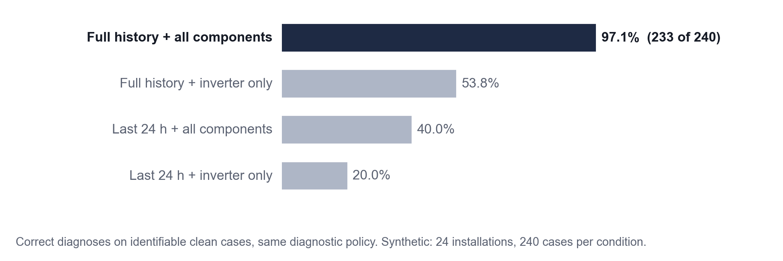
Figure 1. History across components is what makes diagnosis work: the same policy drops from 97.1% to 20.0% with a day of inverter data. Synthetic: 240 cases per condition.
Our vision
We aim to show that a solar data logger can answer an owner's questions with evidence a stranger can check, by running our method on a few real installations whose installers record what they actually found, so that problems are fixed before the lights go off and the savings are there to see, without claiming field accuracy before we have measured it, letting the AI make the engineering call, or building hardware before the data we already have has been tried.

For the team wall: no answer without evidence; no claim without a field check.
Where we are today
What changed since August. The plan was to validate an intelligent layer on real data. The paper now presents a reproducible method with a synthetic worked evaluation. That is the claim the evidence supports. Validation becomes the field phase.
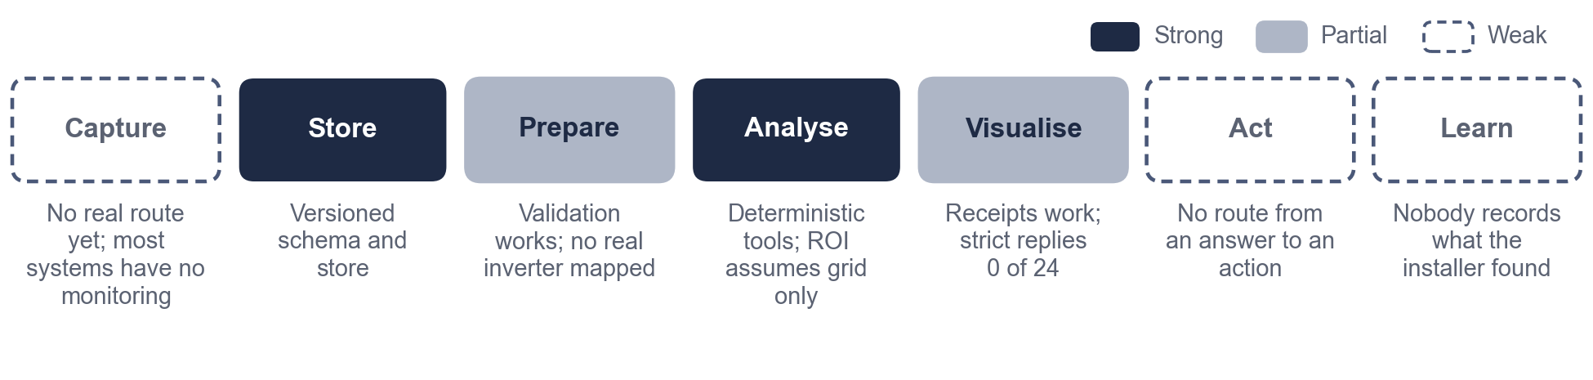
Figure 2. Strong in the middle, weak at both ends: the method analyses well, but nothing real goes in yet, and nothing checks what comes out.
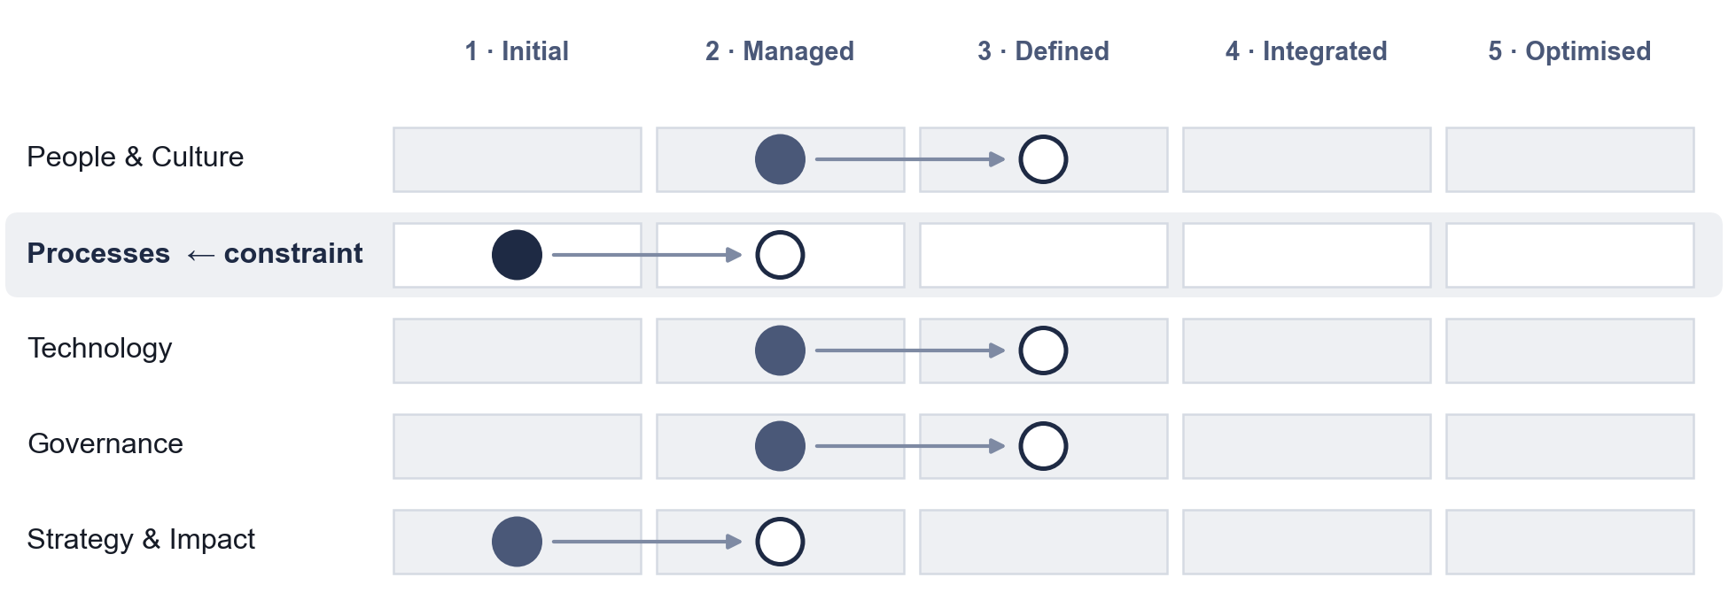
Figure 3. Maturity on real-data operation: filled is today, open is the next level. Processes is the constraint: no real installation's data has flowed through yet.
Limiting constraint: Processes. No real data has flowed through the IDL yet. Strategy & Impact ties at Level 1 and depends on it.
Easy to miss: even a perfect feed would leave the Learn step empty. Without recorded installer findings, no diagnosis can be checked.
How we will know it's working
North Star: field-confirmed diagnoses (M01): diagnoses whose cause matches what the installer recorded on site. Counts, not percentages, until there are 30.
Metric | Today | Decision it informs
M01 Field-confirmed diagnoses | No data | Does the method work in the field?
M02 Sites with a usable weekly feed | No data | Is the manual or export route viable?
M04 Replies in the required structure | 0 of 24 | Can conversational answers be scored?
M05 Replies citing only real measurements | 15 of 24 | Can the prose be trusted?
M06 Days from fault to detection | Synthetic only | Is early detection real?
M07 Installers agreeing to host a site | Pack ready | Pilot size and timing
M08 Cost per site per month | Model about USD 0.21 per 24 conversations | Affordable without funding?

Removed as vanity: tools built, rows generated, tests passed, dashboard visits.
What we fix first
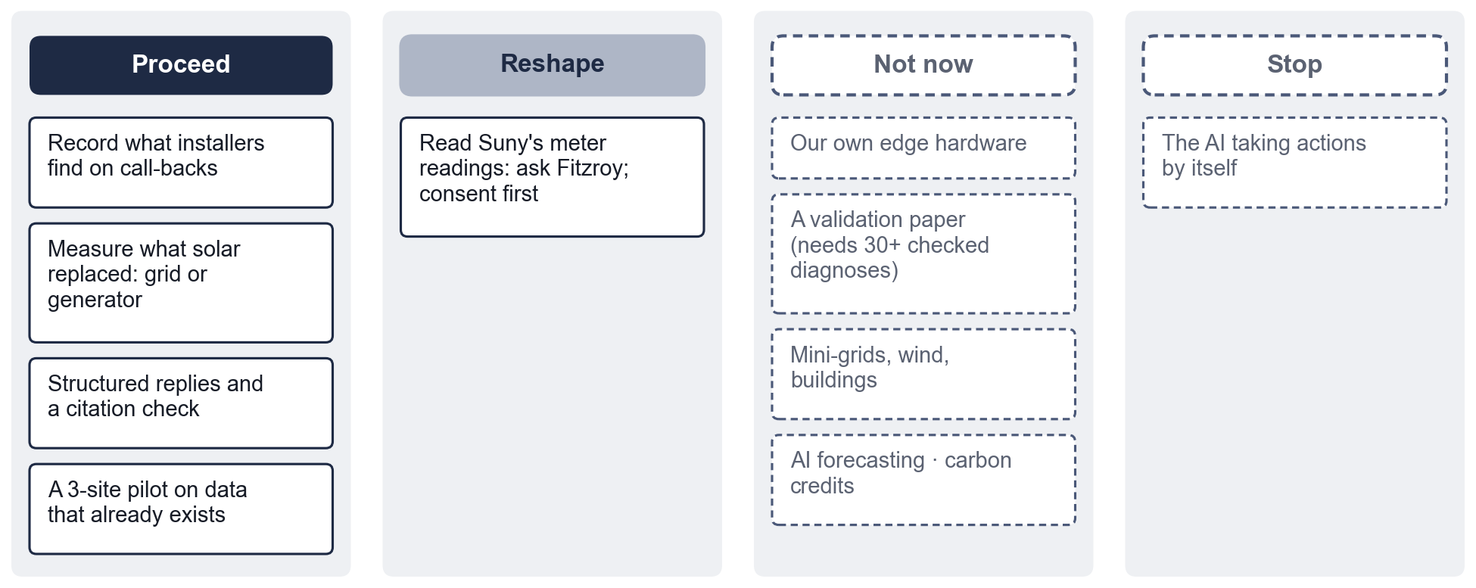
Figure 4. Four things go ahead now. Our own hardware, forecasting, other energy systems and carbon credits are sound ideas, but early.
- Record what installers find on call-backs (I01). A two-line note per visit. It makes M01 measurable.
- Measure what solar replaced (I02). The same 1,851 kWh pays back in 5.1 years against the grid or 0.9 years against a petrol generator. CO₂ avoided is 883 kg vs. 3,481 kg. The logger can see when the grid was on.
- Structured replies with a citation check (I03). The clearest measured failure.
- A three-site pilot on data that already exists (I04). Weekly photos of the inverter counter, plus exports where available. No new hardware.
What we will not do yet
- Claim field accuracy, or that the IDL speeds up solar adoption.
- Build our own edge hardware before the existing data routes are tried.
- Let the AI take actions: dispatch, shutdown or ordering. It explains; people decide.
- Publish any site's data, or send personal data to the model.
- Claim carbon credits, or extend to mini-grids, wind or buildings.
Next 90 days
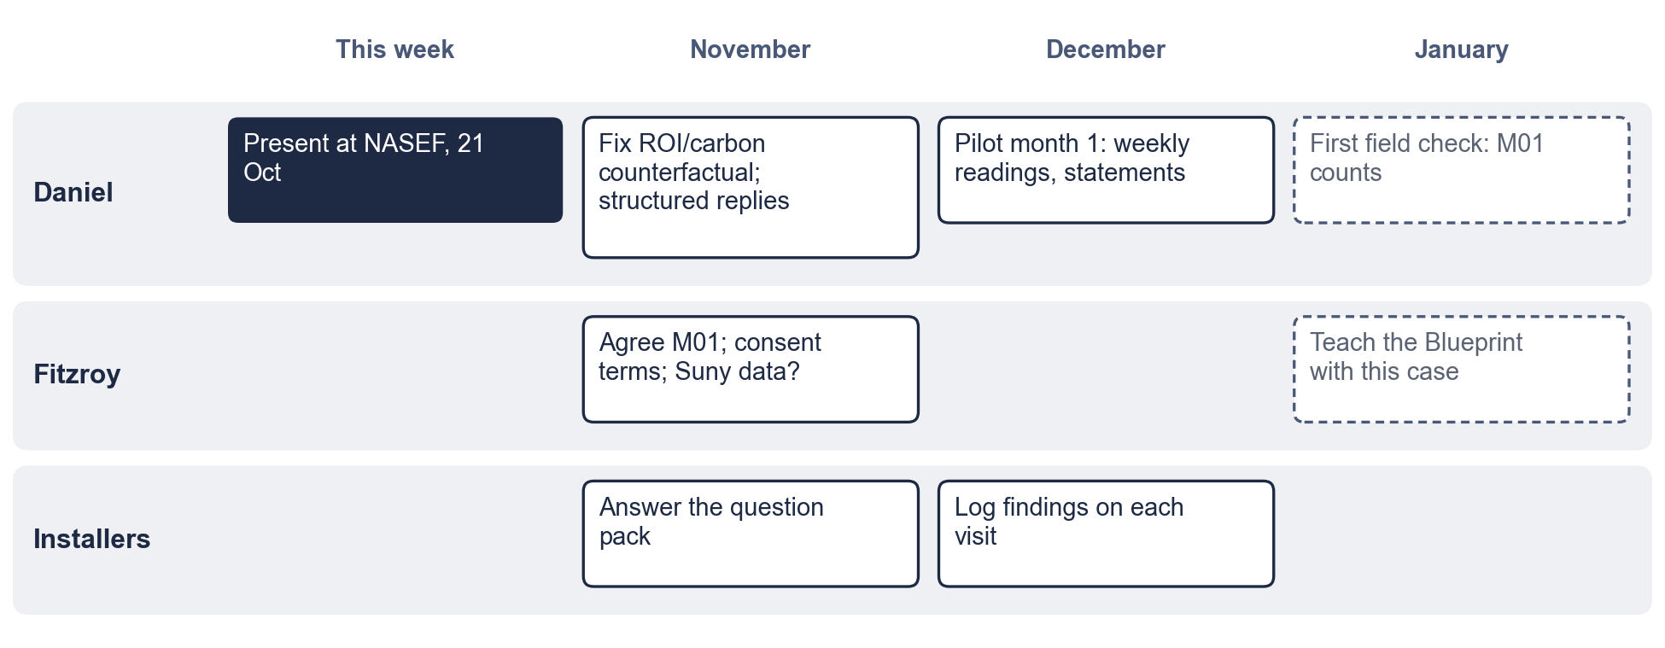
Figure 5. Who does what, and when. NASEF first; the pilot runs in December.
Action | Owner | By | How we'll know it worked
Present the methodology at NASEF | Daniel | 21 Oct | Questions recorded; at least one contact for a pilot site
Send the installer question pack | Daniel | 31 Oct | M07: answers from at least 5 installers
Fix the ROI and carbon counterfactual; use the 0.477 grid factor | Daniel | 15 Nov | The O2 statement shows the grid and generator split
Structured final replies plus a citation check | Daniel | 30 Nov | M04 above 22 of 24 on the pilot set
Agree M01, consent terms, and whether Suny readings can be used | Fitzroy | 15 Nov | A signed one-page consent note
Pilot month 1 at 3 sites | Daniel | 31 Dec | M02: 2 of 3 sites with 28+ days
First field check | Daniel | 31 Jan | M01 counts reported, with n
Teach the Blueprint with this case | Fitzroy and Daniel | Jan | The first workshop runs

Open questions
Question | Who
Talk length and any organiser template | Daniel
The radio-station story: may we tell it, unnamed, with a few numbers? | Daniel
Which survey item showed low maintenance habits, and how many of how many said so? | Daniel
Is "Datalodger" a product, a partner or an earlier name? | Daniel, Fitzroy
Consent and data rights under the NDPA 2023 | Fitzroy
Which installers will host, and which inverters do their customers have? | Installers

Prepared with the Petgrave.io™ Data Strategy Blueprint. Working files: `docs/data-strategy/` (stage files, evidence register, questions, links). All IDL results are synthetic unless stated; small samples are reported as counts.

